**Crop Disease Prediction and Management System**

**Ms. MONISHA GUPTA,SUNKU SAI YASWANTH, GAJJALA AKHILA**

*Assistant Professor in Department of Computer Science and Engineering & Presidency University, Bengaluru*

*Student in Computer Science and Engineering & Presidency University, Bengaluru*

*Student in Computer Science and Engineering & Presidency University, Bengaluru*

---------------------------------------------------------------------***----------------------------------------------------------

**Abstract -**Agriculture plays a critical role in ensuring food security, economic stability, and environmental sustainability. As the demand for higher crop yields intensifies, efficient resource management—particularly fertilizer use—has become essential. The Precision Fertilizer Management project addresses this challenge by utilizing machine learning techniques, specifically Random Forest Regression, to optimize fertilizer application. By analyzing data on soil quality, crop yield, weather patterns, and rainfall, the system generates precise, data-driven recommendations tailored to specific crop needs. This approach minimizes fertilizer waste, reduces environmental impact, and supports sustainable farming practices. With a user-friendly interface and cloud-based accessibility, the project provides a practical, scalable solution for eco-friendly agriculture, even in regions with limited internet access.

**1.INTRODUCTION**

Agriculture remains the backbone of many economies, with food security and crop sustainability being top global priorities. However, crop productivity is continually threatened by inadequate soil fertility management and the prevalence of plant diseases. Early detection and timely intervention are vital to mitigating yield losses and ensuring sustainable agricultural practices.

This research presents the development of a Crop Disease Prediction and Management System, an AI-powered web-based platform designed to assist farmers and agronomists in making informed decisions regarding fertilizer application and plant disease diagnosis. The system integrates two core modules: Fertilizer Recommendation and Plant Disease Detection, both tailored to provide precise and actionable insights.

The Fertilizer Recommendation module allows users to input soil nutrient values (Nitrogen, Phosphorous, and Potassium) along with the crop they intend to grow. The system then processes this data through a trained machine learning model to suggest the most suitable type of fertilizer, thereby supporting the concept of precision fertilization.

In parallel, the Disease Detection module enables users to upload images of affected plants. Leveraging deep learning algorithms, the system identifies the disease and displays relevant information, including its cause and effective preventive or curative measures. For instance, the system can diagnose issues like Cedar Apple Rust in apple crops and suggest pruning and management practices to mitigate spread.

Together, these features demonstrate the potential of digital tools in transforming traditional farming into a more data-driven, efficient, and sustainable practice. By reducing dependency on guesswork and enabling timely interventions, the proposed system aims to empower farmers with accessible technology that enhances crop health and boosts agricultural output.

# 2. LITERATURE SURVEY

Advancements in data-driven techniques, particularly machine learning and artificial intelligence, have revolutionized modern agriculture. Several studies have explored predictive modeling to enhance fertilizer management, crop yield, and disease detection, forming the basis for integrated smart farming systems.

**2.1 Fertilizer Prediction and Nutrient Management**

Hampannavar et al. (2018) developed a model for predicting crop fertilizer consumption using historical agricultural data, which aids in decision-making by optimizing fertilizer usage based on crop and soil patterns【1】. Similarly, Prabakaran et al. (2018) introduced a fuzzy decision support system aimed at improving crop productivity and ensuring the efficient use of fertilizers【2】. These works underscore the potential of AI in reducing over-fertilization, a major contributor to soil and water pollution.

In support of precise nutrient requirement estimation, Yin et al. (2019) examined optimal NPK requirements across diverse Chinese rice-growing environments, highlighting the significance of region-specific fertilizer strategies【3】. Moreover, Hess et al. (2020) investigated how rainfall intensification increases nitrate leaching, especially in till-based systems, further emphasizing the need for precision nutrient application based on environmental conditions【4】.

Nishant et al. (2020) demonstrated the use of machine learning techniques to predict crop yield based on Indian agricultural datasets. Their approach showed significant potential for real-time decision-making in agricultural planning【5】. Yang et al. (2020) highlighted how cropping systems influence soil health, which in turn affects fertilizer needs and plant disease vulnerability【6】.

The smart fertilizer management framework proposed by Agrahari et al. (2021) consolidated weather, soil, and crop data to dynamically adjust fertilizer dosing【7】. This idea has been further extended by Ather et al. (2022), who used artificial intelligence to select manure composition tailored for specific farming needs【8】, and by Swaminathan et al. (2023), who proposed a deep neural collaborative filtering model to recommend fertilizers based on historical input-output patterns【9】.

**2.2 Machine Learning in Crop Yield and Health Prediction**

The broader implications of these models are evident in Gao et al. (2024), where global fertilizer consumption was projected under different socioeconomic pathways, indicating a growing need for optimized and environmentally responsible fertilizer management strategies【10】.

**2.3 Smart and Integrated Agricultural Systems**

Although much of the existing work focuses on specific components such as yield prediction or fertilizer optimization, few systems offer holistic solutions. This research addresses that gap by integrating both disease prediction and fertilizer management into a single intelligent platform. The system utilizes a convolutional neural network (CNN) for plant disease classification from leaf images and a machine learning model—specifically Random Forest—for fertilizer recommendation based on soil nutrients and environmental conditions.

By unifying these functionalities, the proposed system offers a scalable, data-driven tool aimed at empowering farmers, enhancing productivity, and promoting sustainable farming practices.

**3. PROPOSED METHOD**

The Crop Disease Prediction and Management System is proposed as a unified, intelligent decision-support tool that integrates crop recommendation, fertilizer suggestion, and plant disease diagnosis into a single web-based platform. The system leverages both machine learning and deep learning models, combined with real-time weather data, to provide precise and actionable recommendations for farmers.

The proposed method consists of the following components:

1. Data Acquisition

The system gathers input from two sources:

* User Inputs: Soil nutrient values (N, P, K), pH level, rainfall, crop type, and city name (for weather data).
* External APIs: Temperature and humidity values are fetched in real-time from the OpenWeatherMap API based on the user's location.

Additionally, users can upload leaf images of plants for disease identification.

2. Crop Recommendation Model

A Random Forest Classifier is trained on agricultural datasets that include environmental and soil parameters alongside the most suitable crops. The model accepts the following features:

* Nitrogen (N)
* Phosphorus (P)
* Potassium (K)
* Soil pH
* Rainfall (mm)
* Temperature (°C)
* Humidity (%)

Output: Recommended crop name (e.g., *Tomato*, *Rice*, *Sugarcane*)

3. Fertilizer Suggestion Logic

Once the crop is known, the system retrieves the ideal NPK values for that crop from a dataset. It then calculates the deficiency or excess for each nutrient:

ΔN=Nideal−Ncurrent,ΔP=Pideal−Pcurrent,ΔK=Kideal−Kcurrent\Delta ​

The nutrient with the highest deviation is identified, and a recommendation is generated using a predefined logic dictionary (fertilizer_dic) which provides corrective measures.

4. Plant Disease Detection

The disease prediction component uses a deep learning-based ResNet9 CNN model trained on labeled images of healthy and diseased plant leaves.

Workflow:

* Image uploaded by user
* Preprocessing: Resize to 256×256, convert to RGB tensor
* Prediction using the trained model
* Class label is mapped to detailed disease information and remedies using a disease_dic dictionary

Output: Name of the disease (if any) and corresponding treatment or preventive measures

5. Web-Based User Interface

The entire system is hosted as a web application built using Flask. Key features include:

* Input forms for nutrient data and image upload
* Display of real-time weather data
* Clear presentation of crop, fertilizer, and disease predictions
* An optional chatbot interface powered by GPT-4 to assist with agricultural queries

6. Advantages of the Proposed Method

* Integrated Solution: Combines crop selection, fertilizer management, and disease detection in one system.
* Real-Time Intelligence: Uses live weather data for dynamic predictions.
* Accessible Interface: User-friendly, lightweight web app usable in low-connectivity environments.
* Scalability: Designed for deployment on cloud or local servers to support farmers in remote locations.

**4.METHODOLOGIES**

The Crop Disease Prediction and Management System is a web-based application designed to assist farmers with accurate crop and fertilizer recommendations, along with real-time disease detection. The system is built using a combination of machine learning, deep learning, and weather API integration. The methodology consists of the following key components:

1. System Architecture

The system architecture is modular, composed of three core functionalities:

* Crop Recommendation
* Fertilizer Suggestion
* Disease Detection via Image Classification

Each module processes user input through machine learning or deep learning models and returns actionable suggestions via a simple web interface built using Flask.

2. Crop Recommendation Module

This module predicts the most suitable crop based on the input values of:

* Soil nutrients: Nitrogen (N), Phosphorus (P), and Potassium (K)
* pH value of the soil
* Rainfall
* Real-time temperature and humidity (retrieved from OpenWeathe Map API using the user's city input)

A Random Forest machine learning model, trained on a labeled dataset of crop and soil features, processes the inputs. The model outputs the most appropriate crop for cultivation under the given conditions.

Model Input Format:  
N, P, K, temperature, humidity, pH, rainfall, P, K, temperature, humidity, pH, rainfall N, P, K, temperature, humidity, pH, rainfall

3. Fertilizer Recommendation Module

This module takes the selected crop and its current soil nutrient values as input and compares them to ideal nutrient values from a pre-defined CSV dataset. It calculates the nutrient deficiencies or excesses and provides fertilizer recommendations accordingly.

Logic Used:

* Calculate the difference between current and required NPK values
* Identify the nutrient with the greatest deviation
* Use a dictionary-based rule system to return a human-readable suggestion (from fertilizer_dic)

4. Disease Detection Module

This module enables users to upload images of plant leaves. The image is processed using a Convolutional Neural Network (CNN)—specifically, a fine-tuned ResNet9 model trained on the PlantVillage dataset.

Image Processing Pipeline:

* Resize the image to 256x256
* Convert to tensor
* Feed into the ResNet9 model
* Return the predicted class label (e.g., *Tomato___Late_blight*)

The result is mapped to a dictionary (disease_dic) that contains detailed descriptions and suggestions for managing the disease.

5. Web Interface and API Integration

The web application is developed using Flask, a lightweight Python web framework. User input forms and result pages are rendered via HTML templates. Weather data (temperature and humidity) is dynamically fetched using the OpenWeatherMap API based on user-entered city names.

Additionally, the platform includes a chatbot module that uses OpenAI's GPT API to answer farming-related queries in natural language, enhancing interactivity and user support.

6. Deployment

The system is designed to be deployed on a server accessible via browser, using:

* Python (backend)
* Flask (web framework)
* Torch (deep learning)
* Scikit-learn / joblib (machine learning models)

The system is robust, easy to use, and provides recommendations even in low-bandwidth environments, supporting broader accessibility for rural users.

**5.RESULT**

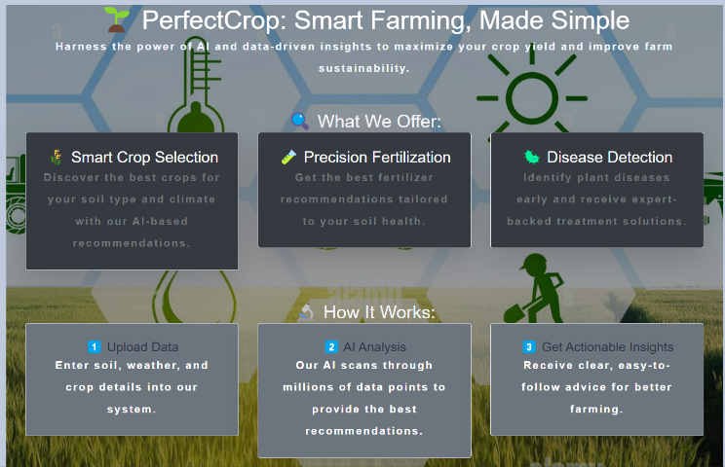

This is the **main interface** that introduces the core features of the system:

* **Smart Crop Selection** using AI to recommend crops based on soil and climate data
* **Precision Fertilization** based on soil nutrient levels
* **Disease Detection** from plant images  
  The dashboard outlines a clear 3-step process:

1. Upload soil/weather/crop data
2. AI analyzes the inputs
3. Get actionable recommendations  
   This serves as the **central hub** for smart, sustainable farming practices.

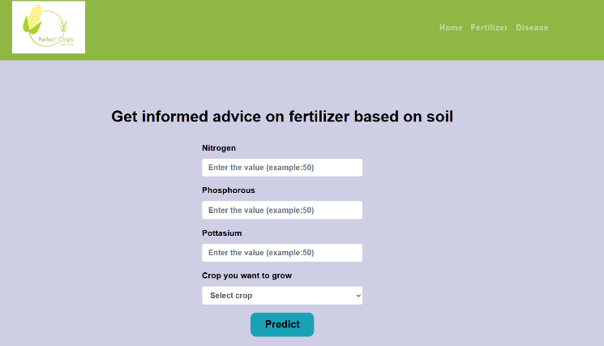

This module allows users to input key soil nutrient values—**Nitrogen**, **Phosphorous**, and **Potassium**—along with their intended crop selection. Using this input, the system predicts the most suitable **fertilizer combination** tailored to the soil’s health and the specific needs of the selected crop. This helps farmers make informed decisions, reduce fertilizer waste, and enhance yield productivity.

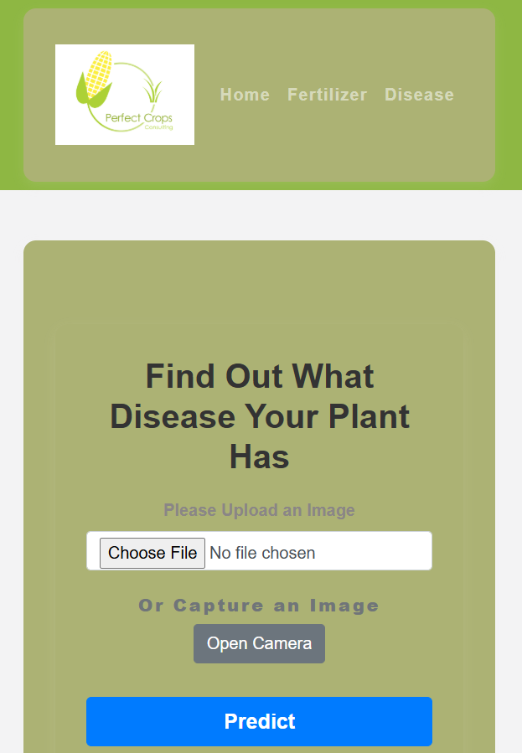

In this feature, users can upload a plant image or capture one using the camera. The system processes the image using a trained model and identifies the plant **disease**. This empowers farmers with quick and accurate diagnostics, enabling **early intervention** and effective treatment, reducing crop loss due to diseases.

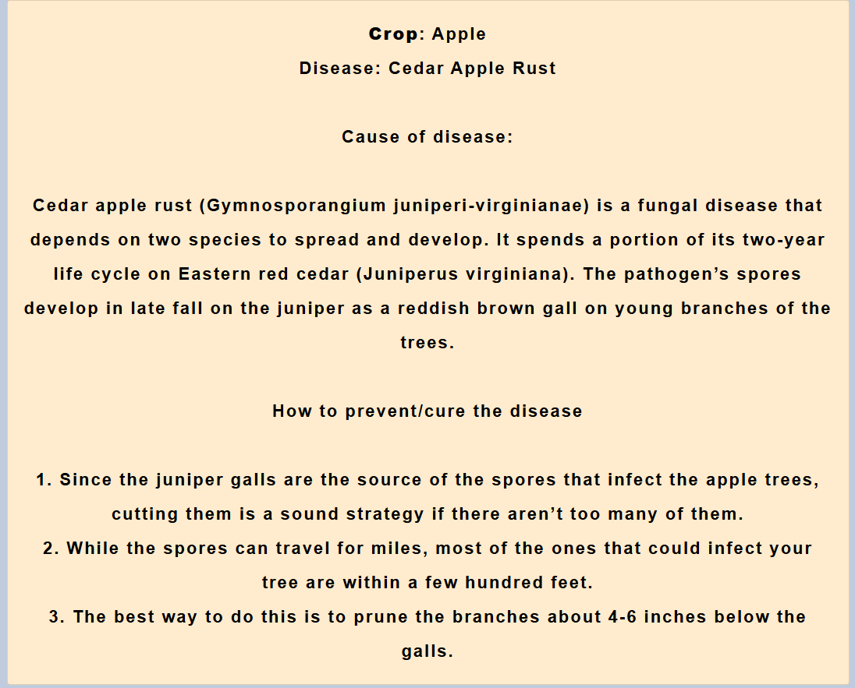

Once a disease is detected, the system displays the **disease name**, **cause**, and most importantly, **preventive and curative measures**. In this example, “Cedar Apple Rust” is identified, and the user is educated on its source and actionable steps such as pruning infected branches and removing galls. This result page serves as a **digital extension of expert agricultural consultation**.

**6.CONCLUSION**

The Perfect Crops project demonstrates the transformative power of AI and machine learning in modern agriculture. By integrating key features such as smart crop recommendation, precision fertilizer suggestion, and real-time disease detection, this platform empowers farmers to make data-driven decisions that enhance crop yield, reduce resource wastage, and mitigate crop diseases early.

The user-friendly interface, coupled with robust backend models, bridges the gap between traditional farming practices and digital innovation. Through this project, we aim to support sustainable farming, improve food security, and pave the way for a smarter, tech-enabled agricultural future.

**7. REFERENCES**

1. Yang, T., Siddique, K. H. M., & Liu, K. (2020). Cropping systems in agriculture and their impact on soil health. Global Ecology and Conservation.
2. Agrahari, R. K., Kobayashi, Y., Tanaka, T. S., Panda, S. K., & Koyama, H. (2021). Smart fertilizer management. Taylor & Francis.
3. Ather, D., Madan, S., Nayak, M., Tripathi, R., Singh, S., & Jain, K. R. (2022). Selection of smart manure composition for smart farming using artificial intelligence technique. Wiley Online Library
4. Swaminathan, B., Palani, S., Subramaniyaswamy, S., & Vairavasundaram, S. (2023).
5. Deep neural collaborative filtering model for fertilizer prediction. Gao, Y., Dong, K., & Yue, Y. (2024). Projecting global fertilizer consumption under shared socioeconomic pathway (SSP). Elsevier.